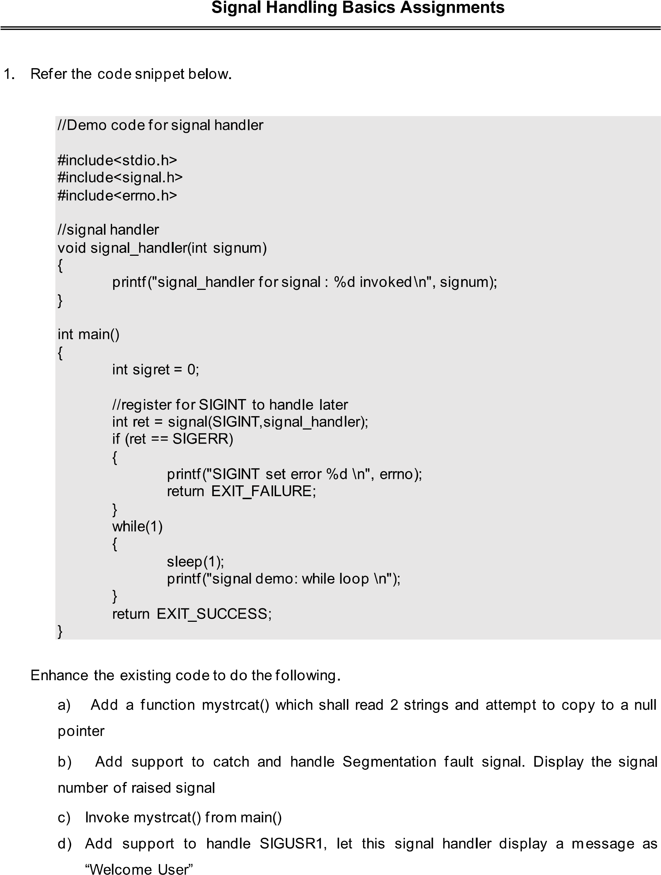

#include <iostream>

#include <signal.h>

#include <sys/types.h>

#include <unistd.h>

#include <signal.h>

#include <sys/wait.h>

#include <errno.h>

#include <cstring>

#define SIZE 40

using namespace std;

static void signal_handler(int ID)

{

cout<<"\nInterrupt signal is ID : "<<ID<<endl;

if(ID == 11)

{

cout<<"\n Seg core dump\n"<<endl;

exit(0);

}

}

char user[SIZE] = "Welcome User!";

char * buf;

void Signal_handler (int sig_num)

{

cout<<buf<<&user<<endl;

exit(0);

}

int main()

{

signal(SIGUSR1, Signal_handler);

cout<<"\n Received SIGUSR1 is : "<<user<<endl;

{

char str1[SIZE] = "System";

char * buf;

buf = strcat( str1, " Programming" );

cout<<"\n Concatenated string is : "<< str1<<endl;

}

{

int count=0;

signal(SIGSEGV, signal_handler);

while (++count)

{

cout << "\n Hello all! Welcome!" << endl;

if (count == 3)

raise(SIGSEGV);

}

return 0;

}

}

